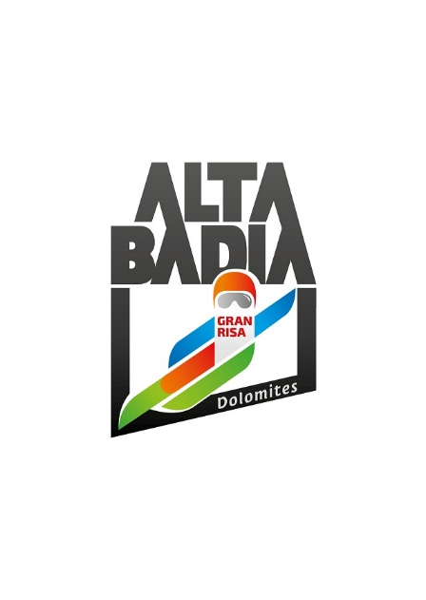PRESS RELEASE

**ALTA BADIA**

**40TH ANNIVERSARY OF THE SKI WORLD CUP**

**ON THE GRAN RISA SLOPE**

**In Alta Badia, preparations are underway for the men’s Alpine Ski World Cup giant slalom and slalom, scheduled for Sunday, December 21, and Monday, December 22, on the Gran Risa slope. To celebrate the 40th anniversary, a photographic exhibition will be set up in the ski area, retracing the most significant moments in the event’s history. Spectators will have the opportunity to experience the event from the stands or the hospitality areas. Ticket sales will open on Wednesday, October 15, on** [**www.skiworldcup.it**](http://www.skiworldcup.it)**.**

**Alta Badia (South Tyrolean Dolomites/Italy)** - The world’s top male alpine ski athletes will compete in Alta Badia in a giant slalom and a slalom scheduled for Sunday, December 21, and Monday, December 22. The renowned ski resort, located in the heart of the Dolomites a UNESCO World Heritage site, boasts a long tradition of hosting Alpine Ski World Cup races: for 40 years, Alta Badia has been one of the most eagerly anticipated stops on the Ski World Cup circuit.

**GRAN RISA CELEBRATES 40 YEARS OF HISTORY AND GREAT CHAMPIONS: A PHOTOGRAPHIC EXHIBITION REVISITING THE MOST SIGNIFICANT MOMENTS**

Gran Risa celebrates the 40th anniversary of its first race, held in 1985: a competition that captured the skiing world and, year after year, has seen some of the greatest international champions descend its spectacular slopes. This iconic course has carved lines of glory in the snow, bearing witness to emotion, courage, and the passion of an entire valley.

To mark this important milestone, a photographic exhibition set up in the ski area tells the story of Gran Risa through images that speak of speed, determination, and legend. It is a tribute to all those who have helped make this course great and to Freddy Planinschek, the official photographer of the event since its first edition, who has captured every turn, every victory, and every emotion through his lens. The exhibition consists of 20 photographs, placed along the most scenic slopes of Alta Badia, offering fans a unique journey through sport, memory, and beauty.

**HOSPITALITY AREAS: SPORT, MUSIC, LIFESTYLE, AND GOURMET EXPERIENCES**

Under the guidance of Andy Varallo, the Organizing Committee works each year to ensure flawless events, constantly introducing improvements and innovations. This edition will again combine sport and lifestyle through the hospitality areas: fans can cheer their champions live, choosing between the parterre stands or three exclusive lounges designed to welcome numerous guests. Each area is based on the destination’s core values: fine cuisine, the majesty of the Dolomites, and Ladin culture.

The excellence of gourmet dining is once again at home in the LEITNER VIP Lounge, located on the rooftop overlooking the Gran Risa. From here, guests can enjoy a privileged view of the races while

spending a few relaxing hours sipping fine wine paired with dishes prepared on Sunday by chefs Herbert Hintner (Restaurant Zur Rose, 1 Michelin star, Appiano) and Pasquale Tozzi (Restaurant La Farmacia Bistrot, Chiari). On Monday, December 22, the culinary experience at the LEITNER VIP Lounge will be led by Tina Marcelli (Restaurant Johanns, Campo Tures) and Johann Lerchner (Restaurant Lerchner’s, San Lorenzo), both awarded the Michelin Green Star. Together, the two chefs will present a four-hand menu combining a passion for local culinary tradition with careful attention to the sustainable sourcing of strictly seasonal ingredients. For sweeter moments, from breakfast to desserts, Ricky Wieser of I Dolci di Ricky, the renowned Alta Badia pastry chef, will delight guests with his gourmand creations. The lounge interiors are modern and elegant, with social areas such as a cozy wine bar and more intimate corners, ideal for business meetings.

Continuous service ensures that throughout the day guests can enjoy some of the finest South Tyrolean products, including speck and cheeses, paired with high-quality wines and sparkling wines, in collaboration with the Alto Adige Wine Consortium and IDM Alto Adige.

Tickets: €315 for Sunday, €230 for Monday.

Inside the Red Bull Energy Station, Alta Badia’s pioneering spirit meets Red Bull’s ambition, creating a unique lounge across the entire World Cup circuit. The facility, featuring a large terrace directly at the finish area, allows fans to watch the races up close, in an experience reminiscent of Formula 1 or MotoGP pit boxes. Furnished with linear-design tables and comfortable sofas spread over two floors, the hospitality area is designed as an open space for use throughout all World Cup days, from breakfast to buffet lunch, and during breaks with hot drinks or energizing beverages, accompanied by DJ music.

Tickets: €250 for Sunday, €220 for Monday.

The most traditional lounge, entirely clad in wood, is the Gran Risa Chalet. This hospitality area is dedicated to Ladin traditions and culture, and for the occasion will host partners Forst, Oakley, and Movimënt. In addition to its mountain-style setup, it offers the opportunity to taste some of the finest local dishes, simple yet authentic.

Tickets for a seat in the stands start at €30 for both Sunday and Monday and can be purchased, along with hospitality area tickets, on [www.skiworldcup.it](http://www.skiworldcup.it).

The World Cup weekend begins on the evening of Saturday, December 20, with the bib draw (7.00 p.m.) in the centre of La Villa, followed by a party organized by the Fire Brigade inside the tent, set up directly on the parterre of the Gran Risa.

**TICKET SALES OPENING AND LAUNCH OF THE NEW MGZN+**

Starting Wednesday, October 15, all types of tickets will be available for purchase directly online at [www.skiworldcup.it](http://www.skiworldcup.it). On November 15, the digital magazine MGZN+ (Magazine Plus) will return with a renewed look, enriched with new content and designed to accompany fans through the world of the Alpine Ski World Cup in Alta Badia.

MGZN+ is a dynamic and engaging platform, offering readers an experience beyond simple reading, with the ability to explore articles through videos and photo slideshows, or continue the experience online via the e-shop button.

**PARTNERS AND SPONSORS: UNITY IS STRENGTH**

The OC Alpine Ski World Cup Alta Badia would like to thank all partners for their support. The partners and sponsors of the World Cup races in Alta Badia are an integral part of the event and contribute to making also this edition unique and special. This confirms the solid relationship that has been established over the years between partners and the OC Alpine Ski World Cup Alta Badia.

**For further information:**

Alpine Ski World Cup Alta Badia – [www.skiworldcup.it](http://www.skiworldcup.it) – Phone +39 0471/830161 – Email: [info@skiworldcup.it](mailto:info@skiworldcup.it)

Tourist Offices Alta Badia – [www.altabadia.org](http://www.altabadia.org) – Phone +39 0471/836176-847037 – Email: [info@altabadia.org](mailto:info@altabadia.org)

**Alta Badia Press Office:**

Nicole Dorigo: Mob. +39 338/9506830 – Email: [press@altabadia.org](mailto:press@altabadia.org)

Stefanie Irsara: Mob. +39 340/8738833 – Email: [stefanie.irsara@altabadia.org](mailto:stefanie.irsara@altabadia.org)