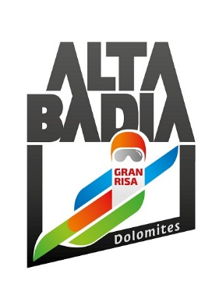
PRESS RELEASE

Alta Badia Giant Slalom

Marco Schwarz Unrivaled on the Gran Risa SLOPE. The Austrian ATHLETE returns to victory after almost two years.

To mark the 40th anniversary of the Ski World Cup in Alta Badia, Marco Schwarz won the giant slalom. Brazil’s Braathen finished second, just 0.18 seconds behind, while Brennsteiner took third place. The slalom will take place on Monday at 10:00am and 1:30pm, and will be broadcast live worldwide.

Alta Badia (South Tyrolean Dolomites/Italy) – In the 40th anniversary edition of the Alta Badia giant slalom, Marco Schwarz, the Austrian born in 1995, secured his first victory on the iconic Dolomite slope, claiming his seventh overall World Cup win. This triumph comes almost two years after his last victory, which took place on 22 December 2023 in the slalom event in Madonna di Campiglio.
Italian snow clearly suits Schwarz. After building a commanding lead over the entire field in the first run, he successfully held off Lucas Pinheiro Braathen's charge in the second run, finishing 0.18 seconds ahead of the Brazilian. A true sportsman, Braathen knelt in tribute to the winner, who returned to the top step of the podium after a long and challenging period. Another Austrian, Stefan Brennsteiner, completed the podium, finishing 0.22 seconds behind. Brennsteiner, who won the giant slalom in Copper Mountain in November, immediately rushed to embrace his compatriot upon his return to victory.
Schwarz lifted the trophy, which was created by the artist Daniele Basso, the author of the sculpture GIGANT, which is traditionally installed at the top of the Gran Risa. This year’s trophy dedicated to the race’s 40th anniversary pays tribute to the local community and the region for their constant support. During the awards ceremony, the two Austrians and the Brazilian celebrated their success in Alta Badia with a toast using bottles of wine provided by Cantina Drusian.
Although he finished only sixth, World Cup leader and defending Alta Badia champion Marco Odermatt still retains a comfortable lead in the overall standings with 805 points, ahead of Schwarz (351) and Norway’s Henrik Kristoffersen (326). In the giant slalom standings, Brennsteiner is in the lead with 305 points, closely followed by Odermatt with 300 points and Schwarz with 252 points.
The show continues tomorrow in Alta Badia, with the focus switching from wide gates to slalom poles. The first slalom run is scheduled for 10am, with the second run at 1.30pm. The race will be broadcast live worldwide.

Official results of the Audi Ski World Cup Giant slalom in Alta Badia :
https://medias2.fis-ski.com/pdf/2026/AL/0045/2026AL0045RLR2.pdf

The interviews of the first three classified athletes:
https://soundcloud.com/fisalpineworldcup

For further information:
Alpine Ski World Cup Alta Badia – www.skiworldcup.it – Phone +39 0471/830161 – Email: info@skiworldcup.it
Tourist Offices Alta Badia – www.altabadia.org – Phone +39 0471/836176-847037 – Email: info@altabadia.org

Alta Badia Press Office:
Nicole Dorigo: Mob. +39 338/9506830 – Email: press@altabadia.org
Stefanie Irsara: Mob. +39 340/8738833 – Email: stefanie.irsara@altabadia.org

