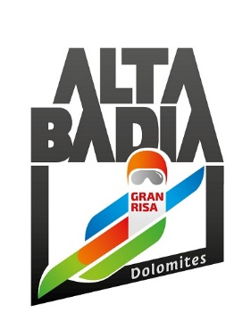
PRESS RELEASE

ALTA BADIA

McGrath: True Love with the Gran Risa
Slalom triumph ahead of Noel and Meillard

The 25-year-old Norwegian claimed victory on the slope that had given him his first World Cup podium in 2020 with a superb second run.

Alta Badia (South Tyrolean Dolomites/Italy) – It is true love between Atle Lie McGrath and the Gran Risa. On the Alta Badia slope, where he secured his first World Cup podium in 2020 with a second-place finish in the giant slalom behind Pinturault, the 25-year-old Norwegian achieved his fourth World Cup victory with an aggressive and decisive second run. France’s Clément Noël, who had been in the lead after the first run, had to settle for second place, finishing 0.30 seconds behind McGrath. Swiss skier Loïc Meillard completed the podium in third place, 0.39 seconds behind.

Euphoric in the finish area, McGrath celebrated his special bond with Alta Badia, further underlined by his third-place finish in last year's slalom: "Here I achieved my first World Cup podium, and winning today on this slope is something truly special. It’s never easy to finish first, and although I’ve often been in a strong position this season, I hadn’t managed it yet. To do it here, in this place, is incredible. I’m absolutely thrilled.”

In the slalom discipline standings, Timon Haugan (who came fourth today) is now in the lead, followed by Clément Noël and Paco Rassat from France. Marco Odermatt remains in the lead of the overall World Cup standings, ahead of Haugan and Lucas Pinheiro Braathen of Brazil.

It was the perfect setting in which to celebrate 40 years since the first race on the Gran Risa. A thrilling weekend in Alta Badia put a smile on the face of Andy Varallo, president of the Alta Badia Ski World Cup organising committee: “We witnessed two truly exciting races. Firstly, Sunday’s giant slalom marked the return to victory of a great champion like Marco Schwarz, who found success again after two years of hard work and sacrifice. Then today, we celebrated Atle McGrath’s slalom victory; he has a special connection with our snow. The Gran Risa is now known all over the world, and there could not have been a better way to celebrate our 40th anniversary than with two races of such a high standard. I would like to thank all the staff and volunteers who made these wonderful days possible through their tremendous efforts over the past few intense weeks. I would also like to take this opportunity to invite everyone to next year’s World Cup. In the meantime, before the next great show, I encourage all ski enthusiasts and their families to come and experience these slopes for themselves: winter in Alta Badia awaits!”
Official results of the Audi Ski World Cup Giant slalom in Alta Badia :
FIS | Audi FIS Ski World Cup Results - Alta Badia (ITA) 2025/2026

The interviews of the first three classified athletes:
https://soundcloud.com/fisalpineworldcup

For further information:
Alpine Ski World Cup Alta Badia – www.skiworldcup.it – Phone +39 0471/830161 – Email: info@skiworldcup.it
Tourist Offices Alta Badia – www.altabadia.org – Phone +39 0471/836176-847037 – Email: info@altabadia.org

Alta Badia Press Office:
Nicole Dorigo: Mob. +39 338/9506830 – Email: press@altabadia.org
Stefanie Irsara: Mob. +39 340/8738833 – Email: stefanie.irsara@altabadia.org

